**Types of Operating System:**

An Operating System performs all the basic tasks like managing files, processes, and memory. Thus operating system acts as the manager of all the resources, i.e. **resource manager**. Thus, the operating system becomes an interface between user and machine.

Some widely used operating systems are as follows-

1. **Single user Operating System:**

A single-user operating system is a type of operating system developed and intended for use on a computer or similar machine that will only have a single user at any given time.

This type of OS is typically used on devices like wireless phones and two-way messaging devices.

Key Points:

Allows a single user to access any particular computer at any one time.

Eg. The Laptop or PC that we use at our home (DOS, Windows, Linux).

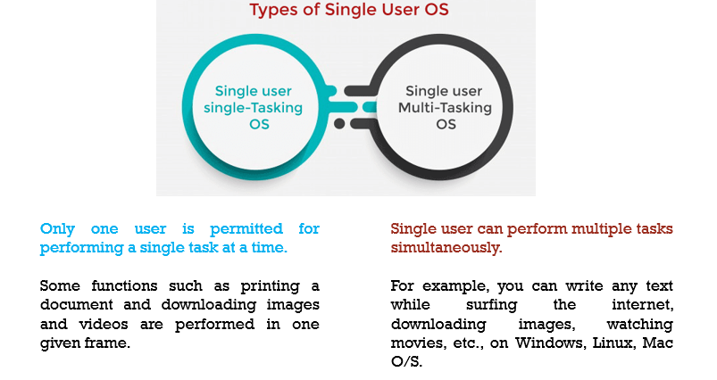

1. **Multi-User Operating System:**

A computer system that allows multiple users that are on different computers to access a single system's OS resources simultaneously.

A multi-user operating system varies from a connected single-user operating system in that each user accesses the same operating system from different machines.

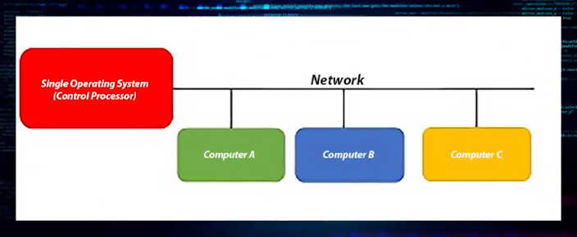

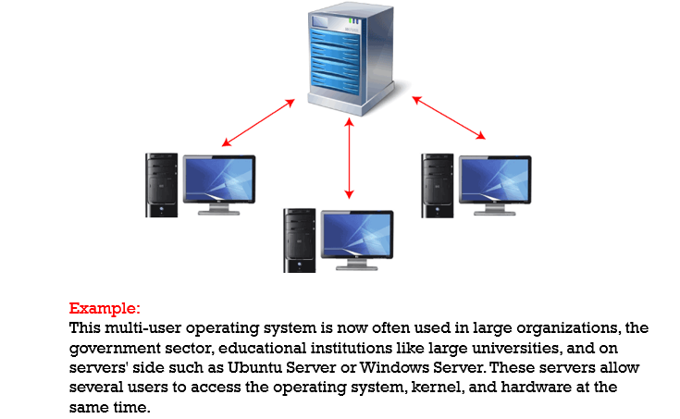

1. **Batch Operating System:**

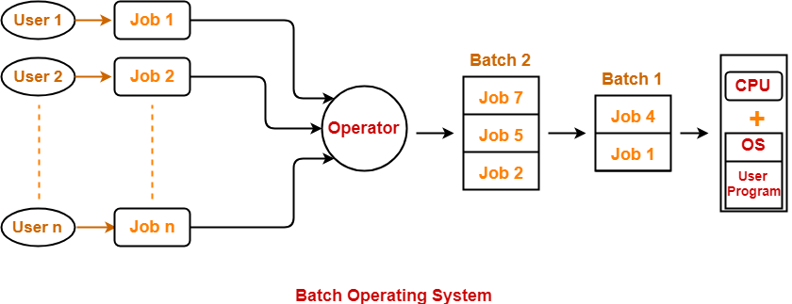

Batch operating system users do not interact with the computer directly

Some computer processes are very lengthy and time-consuming.

► To speed the same process, a job with a similar type of needs is batched together and run as a group.

► Batch OS groups jobs that perform similar type of functions. These groups are called as batch and are executed at the same time.

► The user of a batch operating system never directly interacts with the computer.

► In this type of OS, every user prepares his or her job on an offline device like a punch card and submit it to the computer operator.

► The system put all the jobs in a queue on the basis of first come first serve and then executes the jobs one by one. The users collect their respective output when all the jobs get executed.

Problem with Batch OS-

1. **Sequential execution:** This is one of the major disadvantages of Batch Systems. Jobs in a batch are always executed sequentially. For example, if there are 4 jobs in one batch, then they are always executed one by one and the output is obtained only once all 4 jobs are completed. so Difficult to provide the desired priority.
2. **Starvation:** Different jobs in a single batch might take different amounts of time in execution. This might lead to starvation of some jobs. Suppose there are 4 jobs in a batch and the first job takes too long to execute then the other three jobs in the same batch will have to wait for long until the first one is completed.
3. **No interaction between job and user:** Once a batch is submitted to the computer, the user is no longer able to interact with any of the jobs. Suppose there is a job which requires the user to give the input data during runtime. Now, He must wait until all the jobs in that batch are completed. So, the overall execution time is increased a lot.
4. **Multi- programming operating system:**

Multiprogramming is an extension to the batch processing where the CPU is kept always busy.

Sharing the processor, when two or more programs reside in memory at the same time, is referred as **multiprogramming**. Multiprogramming assumes a single shared processor. Multiprogramming increases CPU utilization by organizing jobs so that the CPU always has one to execute.

An OS does the following activities related to multiprogramming.

* The operating system keeps several jobs in memory at a time.
* This set of jobs is a subset of the jobs kept in the job pool.
* The operating system picks and begins to execute one of the jobs in the memory.
* Multiprogramming operating systems monitor the state of all active programs and system resources using memory management programs to ensures that the CPU is never idle, unless there are no jobs to process.

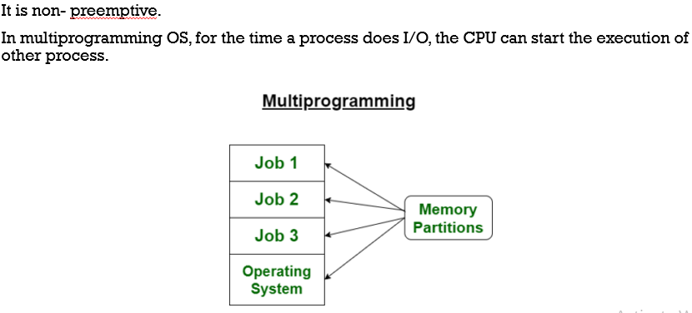

Advantages

* High and efficient CPU utilization.
* User feels that many programs are allotted CPU almost simultaneously.

Disadvantages

* CPU scheduling is required.
* To accommodate many jobs in memory, memory management is required.

1. **Multi-tasking / Time-sharing Operating system:**

In Multiprocessing, Parallel computing is achieved.

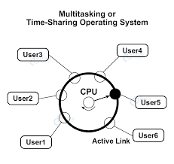

* It is preemptive.
* In multitasking OS, each process is executed for a fixed time period.
* After that fixed time, CPU is switched to other process.
* This fixed time period is called time quantum. It is also called Time –sharing OS.

A time-shared operating system uses the concept of CPU scheduling and multiprogramming to provide each user with a small portion of a time-shared CPU.

Each user has at least one separate program in memory.

A program that is loaded into memory and is executing is commonly referred to as a **process**.

When a process executes, it typically executes for only a very short time before it either finishes or needs to perform I/O.

Since interactive I/O typically runs at slower speeds, it may take a long time to complete. During this time, a CPU can be utilized by another process.

The operating system allows the users to share the computer simultaneously. Since each action or command in a time-shared system tends to be short, only a little CPU time is needed for each user.

As the system switches CPU rapidly from one user/program to the next, each user is given the impression that he/she has his/her own CPU, whereas actually one CPU is being shared among many users.

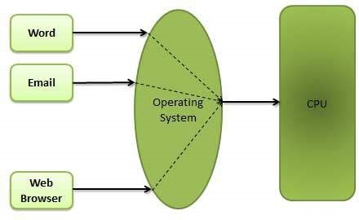

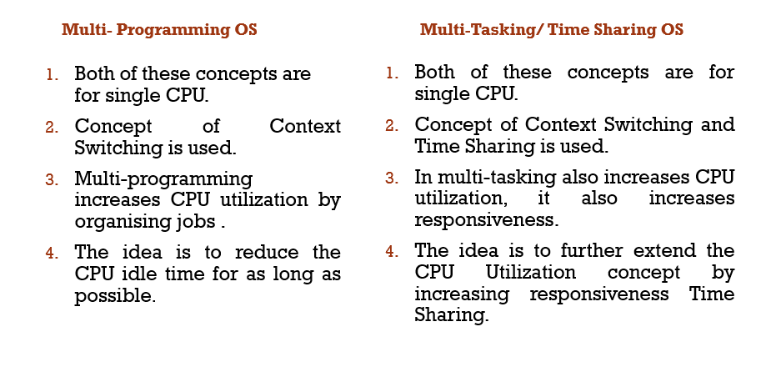

1. **Real Time Operating System:**

These types of OSs serve real-time systems. The time interval required to process and respond to inputs is very small. This time interval is called **response time**.

**Real-time systems** are used when there are time requirements that are very strict like missile systems, air traffic control systems, robots, etc.

**Two types of Real-Time Operating System which are as follows:**

**Hard real-time systems**

► In Hard RTOS, the deadline is handled very strictly which means that given task must start executing on specified scheduled time and must be completed within the assigned time duration.

► Example: Medical critical care system, Aircraft systems, etc. Soft real-time systems

**Soft Real time RTOS,**

It accepts some delays by the Operating system.

In this type of RTOS, there is a deadline assigned for a specific job, but a delay for a small amount of time is acceptable. So, deadlines are handled softly by this type of RTOS.

► Example: Online Transaction system and Livestock price quotation System.

**Examples of Real-Time Operating Systems are:** Scientific experiments, medical imaging systems, industrial control systems, weapon systems, robots, air traffic control systems, etc.

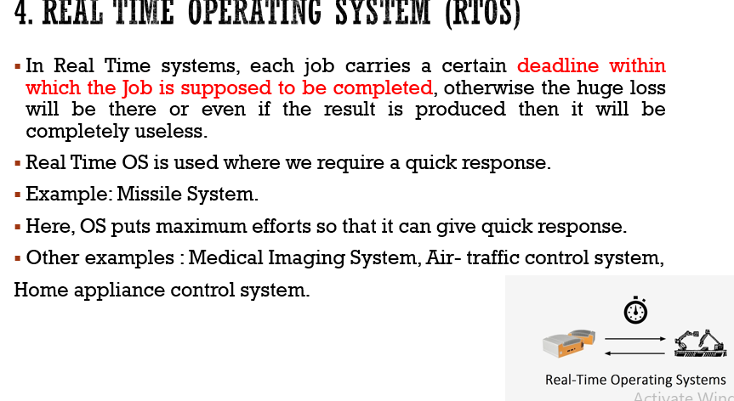

1. **Distributed operating System:**

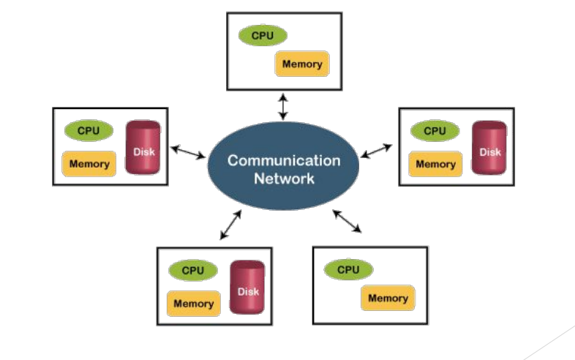

A distributed environment refers to multiple independent CPUs or processors in a computer system. An operating system does the following activities related to distributed environment −

* The OS distributes computation logics among several physical processors.
* The processors do not share memory or a clock. Instead, each processor has its own local memory.
* The OS manages the communications between the processors. They communicate with each other through various communication lines.

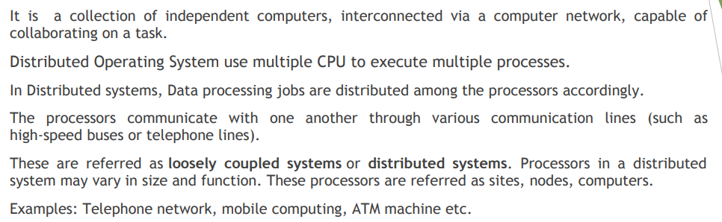

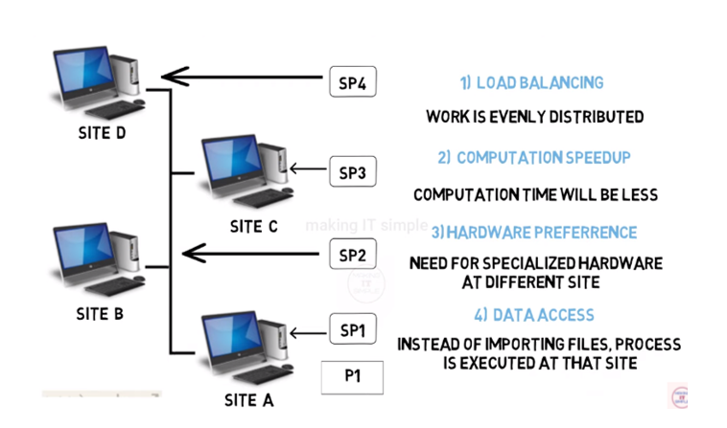

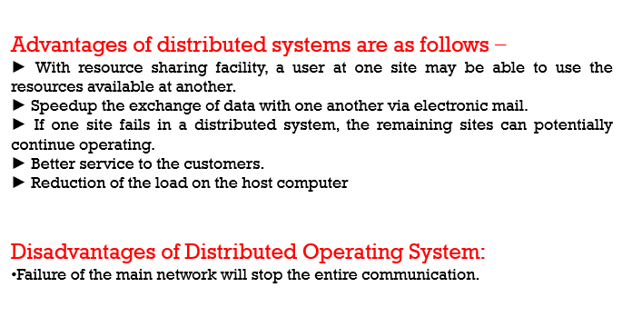

1. **Mobile Operating System:**

A mobile operating system is an operating system that helps to run other application software on mobile devices.

► Much like the Linux or Windows operating system controls your desktop or laptop computer, a mobile operating system is the software platform on top of which other programs can run on mobile devices.

► Some most famous mobile operating systems are Android and iOS, but others include BlackBerry, Web, and watchOS. Popular platforms of the Mobile OS

► Android OS: The Android operating system is the most popular operating system today. It is a mobile OS based on the Linux Kernel and open-source software. The android operating system was developed by Google. The first Android device was launched in 2008.

► Bada (Samsung Electronics): Bada is a Samsung mobile operating system that was launched in 2010. The Samsung was the first mobile to use the bada operating system. The bada operating system offers many mobile features, such as 3-D graphics, application installation, and multipoint-touch.

► iPhone OS / iOS: The iOS was developed by the Apple for the use on its device. The iOS operating system is the most popular operating system today. It is a very secure operating system.

► Windows Mobile OS: The window mobile OS is a mobile operating system that was developed by Microsoft. It was designed for the pocket PCs and smart mobiles.